Game Tracker

Author: Dan Masci  
Student #: 200299037  
Professor: Tom Tsiliopoulos  
Course: Enterprise Computing  
Semester: 4/4

# Table of Contents

|  |  |  |
| --- | --- | --- |
| **Table of Contents**  **1 Team Logo**  **2 Application Description**  **3 Typography and Colours**  **3.1 Typography**  **3.2 Colours**  **4 Wireframes** | **…**  **…**  **…**  **…**  **…**  **…**  **…** | **2**  **3**  **3**  **4**  **4**  **4**  **5** |
| **5 Screen Captures** | **…** | **5** |
|  |  |  |
|  |  |  |

# Team Logo



My logo has been given the title of “MasciApps” – which is the brand of all of my projects and assignments. The logo has a geometric “building-block” feel to it with appropriate colours that match the website’s colour scheme. The “M” of “Masci” and “A” of “Apps” are found within the logo to complement the title. Gradients have been chosen to add more a design appeal to the logo. With the Title and Image, I attempt to demonstrate the services I provide: Design and Development of Applications. “Apps” has been given the darker colour to make it of higher importance.

*Edit:* The gradient has been removed from “MasciApps” because of difficulty to read on top of certain colours.

# Application Description

This **Game Tracker** application will be used to allow users to stay up to date with weekly stats of the games they love – whether it be Basketball, Soccer, Hockey or Football. People can view this application as an anonymous user or register to gain administrative privileges.

The Main Page of this application will display all the games and teams that have been entered into the system. They will be filtered by calendar week, allowing users to jump to a desired date. You will be able to choose whether you want to filter the data by Team or by Game. The date, team logos, team names, scores, winner, loser and spectator count will all be available for each game that is shown.

Users who are registered in our system will be given the opportunity to update their profile information. They will be permitted to enter new teams and new games; or edit existing teams and games. Anonymous users will simply be able to view the data, and nothing more.

This application is built on the foundation of my personal portfolio – providing **Game Tracker** with its own page on the site.

# Typography and Colours

## Typography

Lato is used as the single font across my web application. It is of the typeface family “sans serif” and provides a strong and stable structure. It is a font that works great no matter the font-size used. Because there are no major headings on my site, there is no need for special fonts. I want a clean, consistent and friendly font that won’t strain users’ eyes nor have them second guess while reading. Lato accomplishes just this.

## Colours

Blue has been chosen as the base colour of this application. It is one of the easiest colours to work with in web design and has a sleek look to it. Choosing Darker-Blue as the color of choice, I used simple design standards to pick 3 other blues that are monochromatic or shades. To complement the blue-grey, I use a silver color as some backgrounds and font-colour when on top of dark-blue backgrounds. The Dark-blue I have is used for font; whereas the other 3 blues are used for highlighting, bordering, backgrounds and buttons. Light-blue is the color of choice for GameTracker-specific styling.

Light-blue: #5271CC

Dark-blue: #3F507F

Darker-blue: #0F1F4D

Blue-grey: #3D4766

Silver: #D4CDE5

For specific areas within the application a custom Red, Yellow and Green have been found that do not clash with the rest of the colours.

Red: #5A271A

Yellow: #CBA33C

Green: #629916

# Wireframes

<https://moqups.com/minimasci/cgaffuCR>

# Screen Captures

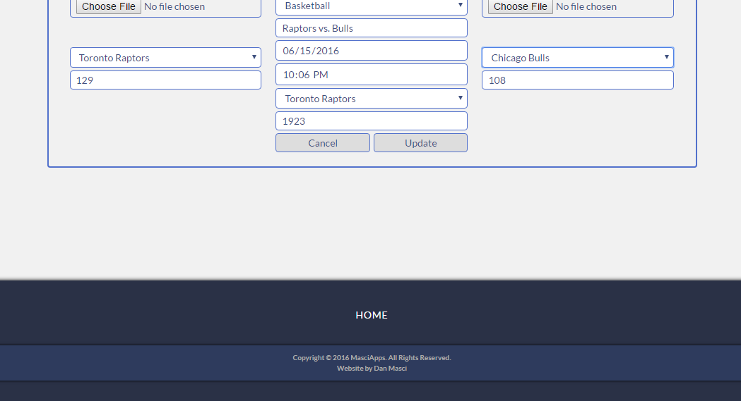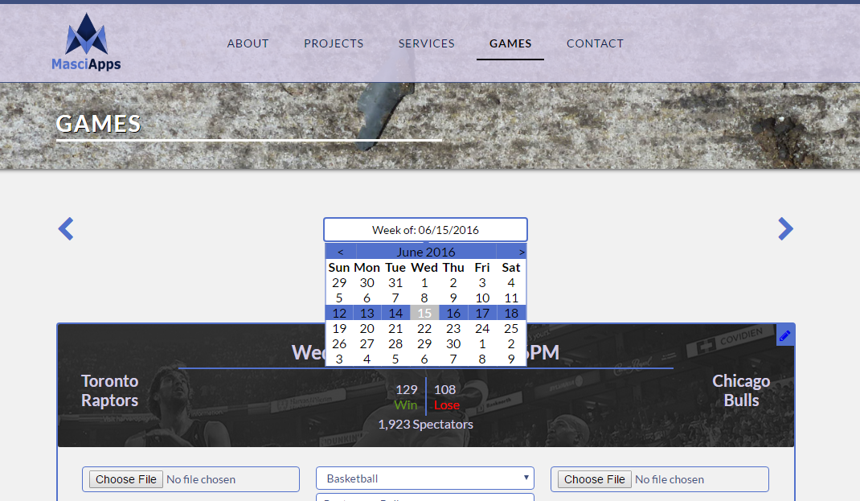Main Game Tracking Page. Currently displaying the game in Edit Mode (form is hidden until Edit Icon is clicked). Calendar appears/disappears on click of the input. Left and Right arrows moves the calendar back or forward by 1 week (Sunday to Saturday) and filters the games appropriately.

Bottom half of the Main Game Page. Home Team on the left and Away Team on the right. Labels for inputs will be added at a later time.

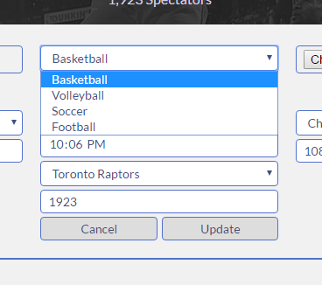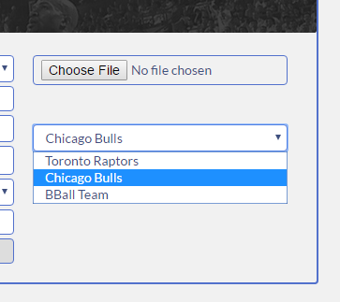The DropDownLists contain dynamic data. Home Team and Away Team will only display Teams of the Type of Game they belong to. Maple Leafs cannot be registered into a Basketball game. Any Hockey, Soccer or Football teams will be excluded from the DropDownList Data until that game is chosen.